Guide for reading, study, and discussion of
Balcony on the Moon
Coming of Age in Palestine
By Ibtisam Barakat

Prepared by: Betsey Coleman
Upper School English Teacher
Distinguished Award in Teaching Fullbright
websites: https://sites.google.com/site/artsandidentity/
And betseycoleman.com
Note: Thanks to Erin Carlson whose guide based on Sandra Cisneros’ House on Mango Street inspired me.
The Poem “Curfew” is published with permission of Ibtisam Barakat.
Professional Reviews:  A poetic, deeply felt coming-of-age story."  *Starred Review. Kirkus Reviews, 2016  "Brimming with humor, wisdom, and empathy."  *Starred Review. Publishers Weekly, 2016  * "Wonderful. . . Not to be missed." Starred Review. VOYA, 2016  "Strums with authenticity."  - Book Page, 2016 | 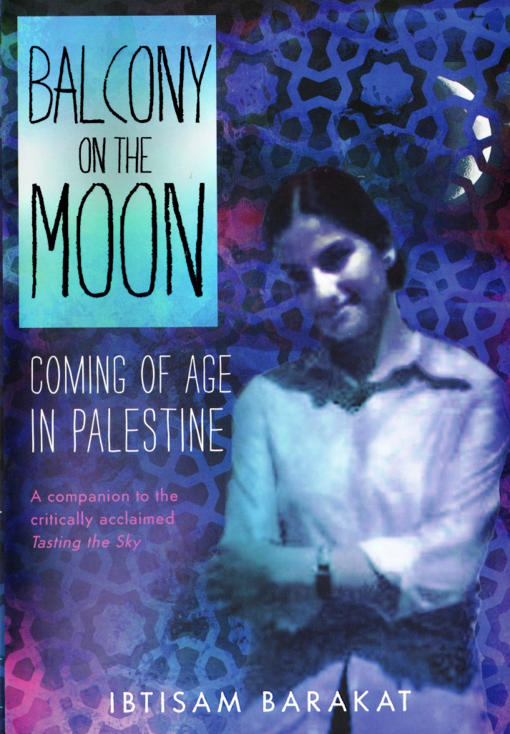
224 pages. ISBN: 978-0-374-30251-1

I
TO THE TEACHER AND READER:

Ibtisam Barakat’s intense memoir details her life as she came of age in Palestine from 1972 – 1981, a politically turbulent time in Palestine’s history in particular and Middle Eastern history in general. The book explores several timely and important themes, including human rights and equality, the costs of wars and unresolved racial strife, and the necessity of education for girls worldwide. Balcony on the Moon is the companion to Barakat’s groundbreaking and critically acclaimed earlier memoir, Tasting the Sky, A Palestinian Childhood (FSG, 2007)

About the author:  Ibtisam Barakat  is an award-winning, Palestinian-American author, poet, translator, artist and educator. Barakat was born in Beit Hanina, East Jerusalem, and grew up in Ramallah, Palestine. She came to the United States for an internship at The Nation magazine in New York City. She holds two Masters degrees, and has taught Language Ethics at Stephens College. Her work centers on healing social injustices, especially in the lives of young people. She authors in both English and Arabic and her writings have been translated into many languages. For more about the author visit her website: www.ibtisambarakat.com | 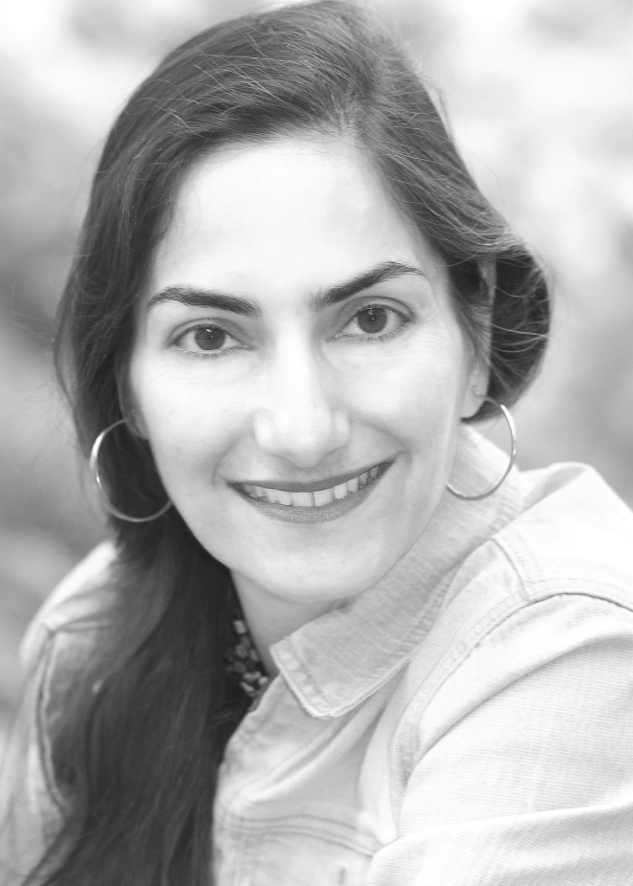
*Visit author’s website to hear the correct pronunciation of her name. | *Listen to the author’s TEDx talk speaking about language: Songs of My foreign Accent

PREPARING TO READ
To the readers/students: For the next few weeks we will be reading and studying Ibtisam Barakat’s memoir Balcony on the Moon, Coming of Age in Palestine. The memoir is made up of 5 parts. Each section has approximately 4 chapters. It is told from the point of view of Ibtisam Barakat, coming of age as a Palestinian girl living in the Israeli Occupied West Bank during the decade of 1971-1981. The book follows Barakat’s memoir Tasting the Sky, a Palestinian Childhood.

We will be addressing different subjects and themes for the memoir.
Pre-reading idea 1:
Essential question
- Where does a person’s sense of identity come from?
Related questions:
- How does environment shape a person’s identity?
- What identities, if any, are permanent, and which one does a person have the power to change in American society?
- What roles do family, the outside world, religion, community beliefs, gender roles, and rebellion play in shaping who a person becomes in American society?
Introducing the Unit:
- Write the question and the related questions on the board and invite the students to respond and discuss. Invite them to consider the question of identity and perhaps generate a list of what they consider their various identities. Explain that these are the questions they’ll be grappling with over the next several weeks, both as they relate to their own lives and as they come to understand Ibtisam, the main character of Balcony on the Moon. Pass out copies of the memoir and have students preview the text. Record on the board or on chart paper any observations the students make about what they see on the covers, flipping through the inside, and looking at chapter headings. After this, students can be invited to share their initial feelings about the text, and use their observations to generate predictions about what they expect to find in the memoir.
- Read the first chapter, “Stone House,” aloud as a class and discuss what is revealed about Ibtisam and her world. Consider how Ibtisam might answer the questions above at this point in the text. The teacher records these observations on chart paper, and adds to them as the class progresses through the memoir.
Pre-researching and critical-thinking Idea 2 Background:
- Ask students what they know about the background of the conflict. Have them research several viewpoints of the conflict: Palestinian, Israeli, Jewish non-Israeli, Arab, Christian, Muslim. If they belong to any of the groups involved, have them interview their family members about it.

- Have students place the conflict in a historical context – what led to this problem? What keeps it going? What does each side want?

- What conflicts in the world are similar to this problem?

- What are the elements of this conflict: for example: the refugee problem, the racial problem, the economic problem, the geographic etc.

- Have the students think about who writes history? And how history as written is not always the way things happened. Have them discuss what is happening now in the present time, and how, depending on who is speaking or writing, it is described in many different ways that include many different truths while neglecting other truths.

Reading and Responding:
Balcony on the Moon is a Coming of Age Memoir. The following discussion questions take into account coming of age themes:
1) Importance of home. Is living in a house your family owns different from living in a house or apartment your family rents? How? Are renters, owners and homeless people all considered equal citizens in America? Why or why not? How important is home to you? Have you always lived in one place? Have you moved houses, states, countries ? Why did your family move?
Everyone needs a home. Why is this especially difficult for Ibtisam?
Discuss what homelessness means to the young Ibtisam. Why does she change homes? Where does Ibtisam live? How many homes does her family live in? What does each represent to her? In Tasting the Sky between the ages of three and seven, Ibtisam was forced to leave her home eight times in four years.
2) Role of language, poetry, and storytelling. Did you know that the role of the poet and storytelling in Muslim culture is preeminent? For example, Al-Mutanabbi (915–965, Iraq), who is known as “the Self-proclaimed Prophet,” continues until today to be regarded by many Arabs as the greatest poet of the Arabic language throughout history. Muslim culture, originally an oral culture, has long embraced and celebrated the role of poetry and epic storytelling. Significant in history of Muslim literature is the hakawati or storyteller, who performed in villages, or circles around bonfires, or on the stages of a theater.
Storytelling in Balcony on the Moon
How important is storytelling to Ibtisam? What role does her father play in Ibtisam’s storytelling? How important is language and word play to the emerging poet, Ibtisam? You might not know it, but Ibtisam is a poet as well as a memoirist. Here is one of her poems. What does this poem reveal about her concerns as a poet? As a Palestinian? **
Curfew
Our city is a cell,
children's faces
are replacing
flower pots on
window sills. . .
and we are waiting. . .
From our window bars
of boredom
we enter a spit race --
the one whose spit
reaches farther
is freer. . .
We look to the sky
squint our questions.
We turn the sun into a kite
hold it with a ray
til it is torn up
inside the horizon . . .
And the light is
peeled off the ground
a page in a bedtime story
we do not understand . . .
Our questions remain
a yeast
inside our chests
rising . . .

What does art do for Ibtisam? How does it help her come of age?
3) Importance of family. Of course family relationships play a major role in anyone’s coming of age. In Balcony on the Moon, Ibtisam’s key relationships are with her a) mother b) father and c) two brothers, Basel and Mohammed.

A) Ibtisam’s mother. Ibtisam has a complicated relationship with her mother (most daughters do!) At times she disagrees with her mother’s comments, attitude, and control. At others, she admires her mother’s strength and determination. What does Ibtisam suggest about her mother’s background that makes her the mother, the wife and woman she is in Balcony on the Moon? What is a turning point in the relationship between Ibtisam and her mother? By the end of Balcony, what does Ibtisam really appreciate about her mother? What motivates Ibtisam’s mother to behave the way she does? What are her dreams? Fears? What challenges does she face? Are you empathetic to her? Why or why not? Ultimately, how do Ibtisam and her father see her mother?

B) Ibtisam’s father. Ibtisam’s father is a Palestinian man trying to provide for and protect his family with all of the challenges and disadvantages of living under occupation. What are some of his specific challenges? Why does he despair? Does he support Ibtisam? How does he support her? What traditional expectations do Ibtisam’s parents have for her? What does he think of his wife and her behavior? What is their marriage like? How does he change?
C) Ibtisam’s brothers. As a child Ibtisam is a playmate for her brothers. She is on equal footing with them. However, as Ibtisam, Basel and Mohammed grow older, how does this relationship change? Why? What is the difference between the dreams of her two brothers? How does the occupation impact their education, travel, and employment?
4) Freedom. In what areas of your life are you most free to do what you like? In what areas of your life do you have the least freedom? Consider the roles gender, race, religion, education, economic class, age, talent, and upbringing play in increasing or limiting an individual’s personal freedom. What freedoms do we take for granted? What freedoms do we have that Ibtisam does not have?
Ask the students if they know what the Universal Declaration of Human Rights is. Show the UDHR 4 minute video:
Youtube https://www.youtube.com/watch?v=hTlrSYbCbHE. Tell them the history of the UDHR. Where and when does Ibtisam talk about the UDHR? Why is it so important? Which parts does she try to stand up for? Why? Consider how important t the UDHR is to Ibtisam. Which rights is she particularly concerned with? Which rights are you particularly concerned with?
*Do you know that Ibtisam wrote a short story about article 18 in the UDHR which was published by Amnesty International in an anthology titled FREE? that celebrated the 60th anniversary of the UDHR? You can find it and read it.

5) Being a refugee. What is a refugee? What is an immigrant? What are Ibtisam and her family? What have they fled from? The teacher could share information about the Nakba of 1948, the 1967 Arab–Israeli War, the Arab-Israeli War of 1973, and the South Lebanon conflict, and create a timeline.
What did these events mean for Palestinian families like Ibtisam’s? At the end of the book, she is about to move. Will she be a refugee and immigrant or something else? Read about what happened to Ibtisam after she came to the U.S, and became a writer.

6) The Outside World and The Occupation. Share a timeline with students about the events happening during both Tasting the Sky and Balcony on the Moon. Do these events form a Palestinian perspective. Another theme for coming of age is the outside world. How does the outside world impact Ibtisam’s life?
Look at for a comparison of events from two perspectives: http://pov-tc.pbs.org/pov/pdf/promiese/promises-timeline.pdf Pages 3-6
7) Importance of gender and rebellion. Should parents/guardians raise their teenage girls in the same way that they raise their teenage boys during times of war? Why or why not? What rules should be the same for girls and boys? What should be different? Do you have brothers, sisters, cousins, etc. who are treated differently from you because of gender? Explain.
This is a story of a young girl coming of age in a traditional culture /society. What are Ibtisam’s challenges as a girl, as a young woman? What are the expectations of her parents? Is Ibtisam rebellious? This is a memoir of a young woman’s coming of age in a society that does not always encourage the daring behavior of women. Where do you see Ibtisam’s challenges impacting her choices as a young woman? Consider employment, education, and marriage.

8) Role of religion. Being Muslim is important in this memoir, but not always central. Ibtisam is a Muslim. How important is her religion to her? How does it affect her coming of age? The young writer often considers what Muslims have in common with Jews and Christians. Where in the memoir do you find this? How does Ibtisam define herself and her identity as a Muslim?
9) Escape. At the end of the memoir, what is Ibtisam escaping? Many writers end their coming of age stories with a young person escaping (i.e. James Joyce’s Portrait of the Artist as a Young Man). What parts of your life would you most like to escape? Can you escape these elements at some point in your life? If so, how? If not, why not?
Question: What inspires you most in your life? What do you see your future holding for you? What obstacles might stand in your way? In what ways will you attempt to overcome them and achieve your future desires?
Question: What are the top three things that you learned and will remember from reading Balcony on the Moon? If you choose to, feel free to write a note to the author via her website and tell her what you think of her book.
Additional:
Video of Ibtisam reading the chapter DESPAIR from Balcony on the Moon. She is dressed in traditional Palestinian clothes.
https://www.youtube.com/watch?v=sHJLttBxGlM

